## Brainstorm

**TIP**

You can select a sticky note and hit the pencil [switch to sketch] icon to start drawing!

**& idea prioritization**

Use this template in your own brainstorming sessions so your team can unleash their imagination and start shaping concepts even if you're not sitting in the same room.

**10 minutes** to prepare

**1 hour** to collaborate

**2-8 people** recommended

##### Before you collaborate

A little bit of preparation goes a long way with this session. Here’s what you need to do to get going.

**10 minutes**

1. **Team gathering**

Define who should participate in the session and send an invite. Share relevant information or pre-work ahead.

1. **Set the goal**

Think about the problem you'll be focusing on solving in the brainstorming session.

1. **Learn how to use the facilitation tools**

Use the Facilitation Superpowers to run a happy and productive session.

[**Open article**](https://support.mural.co/en/articles/2113740-facilitation-superpowers)

**1**

##### Define your problem statement

What problem are you trying to solve? Frame your problem as a How Might We statement. This will be the focus of your brainstorm.

**5 minutes**

**Team id: B9-3A5E**

##### Project Title:

**IoT Based Safety Gadget For Child Safety Monitoring & Notification**

PROBLEM STATEMENT:

Child tracker helps the parents in continuously monitoring the child's location. They can simply leave their children in school or parks and create a geofence around the particular location. By continuously checking the child's location notifications will be generated if the child crosses the geofence. Notifications will be sent according to the child's location to their parents or caretaker.

Key rules of brainstorming

To run an smooth and productive session

**2**

##### Brainstorm

Write down any ideas that come to mind that address your problem statement.

**10 minutes**

**NALINI S**

**Create a mobile application**

Intimating the child's location through GPS

**Ensuring intact delivery of messages**

**Integration with Cloud Services**

**PAVITHRA T**

**GPS integrated watch to keep track of their child’s movements**

**Parental control features**

**NANDHINI L**

#### 

**Use the Child locator gadget**

**Geofencing the child’s movement**

**Comfortable & easily wearable**

**maintain a record of the child's location**

**VISHNUPRIYAN V**

**Send relevant text messages to parents**

Continuous tracking and updating child’s location

**3**

##### Group ideas

Take turns sharing your ideas while clustering similar or related notes as you go. Once all sticky notes have been grouped, give each cluster a sentence-like label. If a cluster is bigger than six sticky notes, try and see if you and break it up into smaller sub-groups.

**20 minutes**

# Physical Features Database

#### 

**Low levels of radiation**

**Comfortable & easily wearable**

**Secure database**

**Geofencing the child’s movement**

**Water & sweat Proof**

**Better battery life**

**Integration with Cloud Services**

**Measures temperature, pulse rate, heart beat rate of child and notify during emergency**

**4**

##### Prioritize

Your team should all be on the same page about what's important moving forward. Place your ideas on this grid to determine which ideas are important and which are feasible.

**20 minutes**

**Ensuring intact delivery of messages**

#### 

Alerting parent when the child passes a range

**Better battery life**

Geofencing child's loaction

Parental control features

##### After you collaborate

You can export the mural as an image or pdf to share with members of your company who might find it helpful.

Quick add-ons

1. **Share the mural**

**Share a view link** to the mural with stakeholders to keep them in the loop about the outcomes of the session.

1. **Export the mural**

Export a copy of the mural as a PNG or PDF to attach to emails, include in slides, or save in your drive.

Keep moving forward

**Strategy blueprint**

Define the components of a new idea or strategy.

[**Open the template**](https://app.mural.co/template/e95f612a-f72a-4772-bc48-545aaa04e0c9/984865a6-0a96-4472-a48d-47639307b3ca)

**Customer experience journey map**

Understand customer needs, motivations, and

Stay in topic.

Use satellite calling in case of emergency

Defer judgment.

Encourage wild ideas.

Listen to others.

Importance

obstacles for an experience.

[**Open the template**](https://app.mural.co/template/b7114010-3a67-4d63-a51d-6f2cedc9633f/c1b465ab-57af-4624-8faf-ebb312edc0eb)

**Measure the pulse rate and heart beat of children**

Sends the correct location to to the particular number

**maintain a record of the child's location**

Go for volume. If possible, be visual.

Alerting parent when the child passes a range

**Keeping parents informed of the child's location**

**GPS integrated watch to keep track of their child’s movements**

**Create a mobile application**

# UI Tracking location

If each of these tasks could get done without any difficulty or cost, which would have the most positive impact?

**Water & sweat Proo**

**compact and light in weight**

**Strengths, weaknesses, opportunities & threats**

Identify strengths, weaknesses, opportunities, and threats (SWOT) to develop a plan.

|  |  |
| --- | --- |
|  |  |
|  |  |

[**Open the template**](https://app.mural.co/template/6a062671-89ee-4b76-9409-2603d8b098be/ca270343-1d54-4952-9d8c-fbc303ffd0f2)

**Low levels of Radiation**

Alerting parent when the child passes a range

**Geofencing the child’s movement**

[**Share template feedback**](https://muralco.typeform.com/to/CiqaHVat?typeform-source=app.mural.co)

**Sends the exact location of child in case of emergency**

**Alerts if the given range is exceeded**

**User friendly application**

Brilliant UI/ UX design for Application

**Brilliant UI/ UX design for Application**

#### 

[**Share template feedback**](https://muralco.typeform.com/to/CiqaHVat?typeform-source=app.mural.co)

Feasibility

Regardless of their importance, which tasks are more feasible than others? (Cost, time, effort, complexity, etc.)

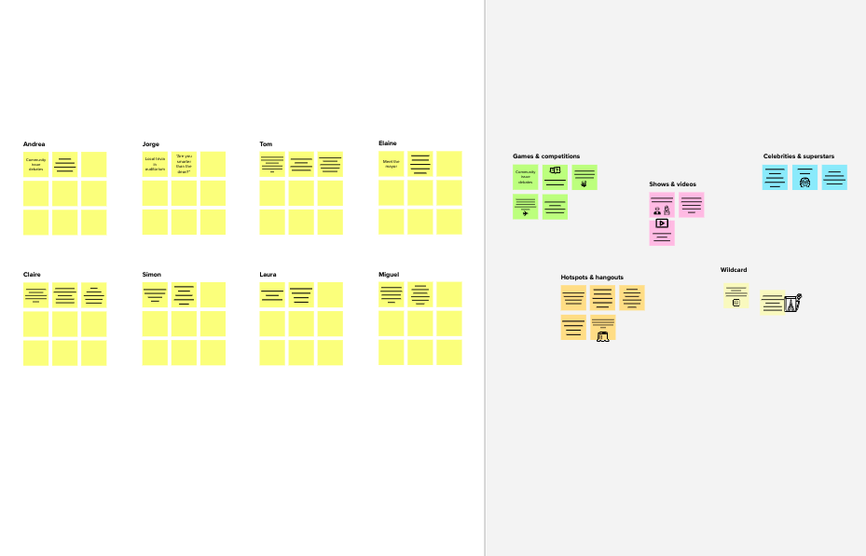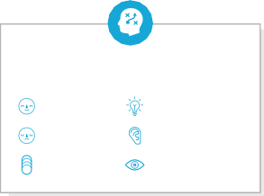

**Template**

**Need some inspiration?**

See a finished version of this template to kickstart your work.

[**Open example**](https://app.mural.co/template/e5a93b7b-49f2-48c9-afd7-a635d860eba6/93f1b98d-b2d2-4695-8e85-7e9c0d2fd9b9)